# Sequence Diagram

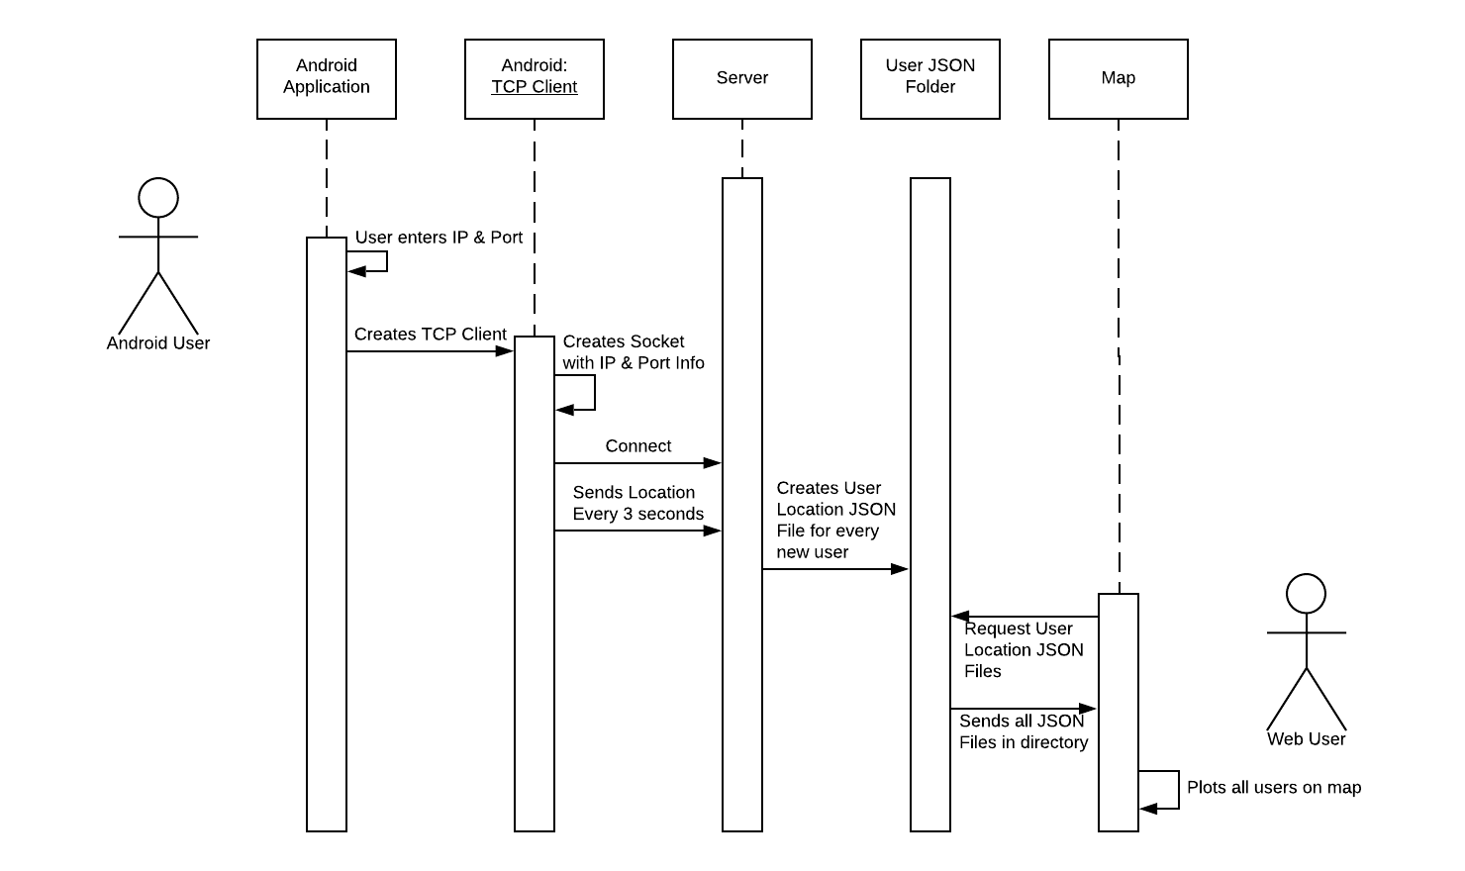

# Deployment DiagramC:\Users\benzh\Downloads_Blank UML (1).png